LAB 26 Configure and Verify a Site-to-Site IPsec VPN
Using CLI

Addressing Table

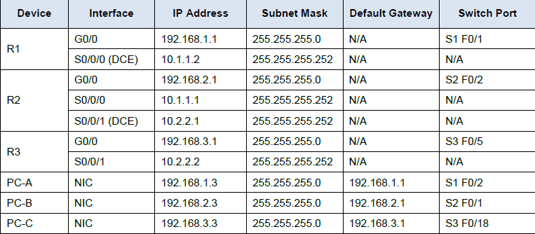

Objectives
• Verify connectivity throughout the network.
• Configure R1 to support a site-to-site IPsec VPN with R3.
Background / Scenario
The network topology shows three routers. Your task is to configure R1 and R3 to support a site-to-site IPsec
VPN when traffic flows between their respective LANs. The IPsec VPN tunnel is from R1 to R3 via R2. R2 acts as a pass-through and has no knowledge of the VPN. IPsec provides secure transmission of sensitive
information over unprotected networks, such as the Internet. IPsec operates at the network layer and protects
and authenticates IP packets between participating IPsec devices (peers), such as Cisco routers.

ISAKMP Phase 1 Policy Parameters

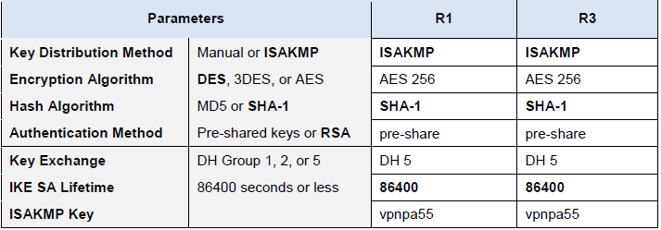

Note: Bolded parameters are defaults. Only unbolded parameters have to be explicitly configured.

IPsec Phase 2 Policy Parameters

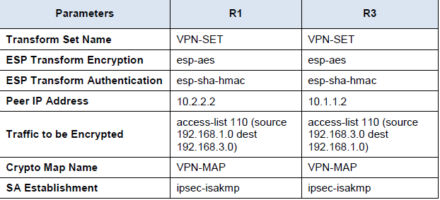

The routers have been pre-configured with the following:
• Password for console line: ciscoconpa55
R1(config)# line con 0
R1(config-line)# password <your_console_password>
R1(config-line)# login
R1(config-line)# exit
• Password for vty lines: ciscovtypa55
R1(config)# line vty 0 4
R1(config-line)# password <your_password>
R1(config-line)# login
R1(config-line)# exit
• Enable password: ciscoenpa55
R1(config)# enable secret <your_enable_secret_password>
• SSH username and password: SSHadmin / ciscosshpa55
• OSPF 101

Part 1: Configure IPsec Parameters on R1
Step 1: Test connectivity.
Ping from PC-A to PC-C.
Step 2: Enable the Security Technology package.
a. On R1, issue the show version command to view the Security Technology package license information.
b. If the Security Technology package has not been enabled, use the following command to enable the
package.
R1(config)# license boot module c1900 technology-package securityk9
c. Accept the end-user license agreement.
d. Save the running-config and reload the router to enable the security license.
e. Verify that the Security Technology package has been enabled by using the show version command.
Step 3: Identify interesting traffic on R1.
Configure ACL 110 to identify the traffic from the LAN on R1 to the LAN on R3 as interesting. This interesting
traffic will trigger the IPsec VPN to be implemented when there is traffic between the R1 to R3 LANs. All other
traffic sourced from the LANs will not be encrypted. Because of the implicit deny all, there is no need to
configure a deny ip any any statement.
R1(config)# access-list 110 permit ip 192.168.1.0 0.0.0.255 192.168.3.0 0.0.0.255
Step 4: Configure the IKE Phase 1 ISAKMP policy on R1.
Configure the crypto ISAKMP policy 10 properties on R1 along with the shared crypto key vpnpa55. Refer
to the ISAKMP Phase 1 table for the specific parameters to configure. Default values do not have to be
configured. Therefore, only the encryption method, key exchange method, and DH method must be
configured.
Note: The highest DH group currently supported by Packet Tracer is group 5. In a production network, you
would configure at least DH 14.
R1(config)# crypto isakmp policy 10 # This creates an ISAKMP (IKE Phase 1) policy with priority 10. Lower numbers indicate higher priority.
R1(config-isakmp)# encryption aes 256 # This sets the encryption algorithm for the policy to AES-256, providing strong encryption for secure communication.
R1(config-isakmp)# authentication pre-share # This specifies the authentication method as Pre-Shared Key (PSK), used for verifying the identity of peers.
R1(config-isakmp)# group 5 # This sets the Diffie-Hellman (DH) group to 5, which uses a 1536-bit key for secure key exchange.
R1(config-isakmp)# exit # This exits the ISAKMP policy configuration mode and returns to global configuration mode.
R1(config)# crypto isakmp key vpnpa55 address 10.2.2.2
Step 5: Configure the IKE Phase 2 IPsec policy on R1.
a. Create the transform-set VPN-SET to use esp-aes and esp-sha-hmac.
R1(config)# crypto ipsec transform-set VPN-SET esp-aes esp-sha-hmac

# This command creates an IPSec transform set named "VPN-SET".
# - "esp-aes": Specifies that the encryption protocol used is ESP (Encapsulation Security Payload) with AES (Advanced Encryption Standard).
# - "esp-sha-hmac": Specifies the integrity protocol used is ESP with SHA (Secure Hash Algorithm) for authentication and integrity checking using HMAC (Hash-based Message Authentication Code).
# The transform set defines how IPSec will secure the traffic, combining encryption and integrity methods.
b. Create the crypto map VPN-MAP that binds all of the Phase 2 parameters together. Use sequence
number 10 and identify it as an ipsec-isakmp map.
R1(config)# crypto map VPN-MAP 10 ipsec-isakmp
R1(config-crypto-map)# description VPN connection to R3
R1(config-crypto-map)# set peer 10.2.2.2
R1(config-crypto-map)# set transform-set VPN-SET
R1(config-crypto-map)# match address 110
R1(config-crypto-map)# exit
Step 6: Configure the crypto map on the outgoing interface.
Bind the VPN-MAP crypto map to the outgoing Serial 0/0/0 interface.
R1(config)# interface s0/0/0
R1(config-if)# crypto map VPN-MAP
Part 2: Configure IPsec Parameters on R3
Step 1: Enable the Security Technology package.
a. On R3, issue the show version command to verify that the Security Technology package license
information has been enabled.
b. If the Security Technology package has not been enabled, enable the package and reload R3.
Step 2: Configure router R3 to support a site-to-site VPN with R1.
Configure reciprocating parameters on R3. Configure ACL 110 identifying the traffic from the LAN on R3 to
the LAN on R1 as interesting.
R3(config)# access-list 110 permit ip 192.168.3.0 0.0.0.255 192.168.1.0 0.0.0.255
Step 3: Configure the IKE Phase 1 ISAKMP properties on R3.
Configure the crypto ISAKMP policy 10 properties on R3 along with the shared crypto key vpnpa55.
R3(config)# crypto isakmp policy 10
R3(config-isakmp)# encryption aes 256
R3(config-isakmp)# authentication pre-share
R3(config-isakmp)# group 5
R3(config-isakmp)# exit
R3(config)# crypto isakmp key vpnpa55 address 10.1.1.2
Step 4: Configure the IKE Phase 2 IPsec policy on R3.
a. Create the transform-set VPN-SET to use esp-aes and esp-sha-hmac.
R3(config)# crypto ipsec transform-set VPN-SET esp-aes esp-sha-hmac
b. Create the crypto map VPN-MAP that binds all of the Phase 2 parameters together. Use sequence
number 10 and identify it as an ipsec-isakmp map.
R3(config)# crypto map VPN-MAP 10 ipsec-isakmp
R3(config-crypto-map)# description VPN connection to R1
R3(config-crypto-map)# set peer 10.1.1.2
R3(config-crypto-map)# set transform-set VPN-SET
R3(config-crypto-map)# match address 110
R3(config-crypto-map)# exit
Step 5: Configure the crypto map on the outgoing interface.
Bind the VPN-MAP crypto map to the outgoing Serial 0/0/1 interface. Note: This is not graded.
R3(config)# interface s0/0/1
R3(config-if)# crypto map VPN-MAP
Step 6 : Configure OSPF on both routers R1 and R3
R1:
R1(config)# router ospf 101
# This command initiates the OSPF (Open Shortest Path First) routing process with Process ID 101.
# The Process ID is a unique number used to identify the OSPF process on the router.
# Each OSPF process can have its own set of configurations and routing information.

R1(config-router)# log-adjacency-changes
# This command enables logging of adjacency state changes in OSPF.
# When there is a change in the state of the OSPF adjacency (connections between OSPF routers),
# this information will be logged to help with troubleshooting and network monitoring.

R1(config-router)# network 10.1.1.0 0.0.0.3 area 0
# This command specifies that the network **10.1.1.0** with a **wildcard mask of 0.0.0.3** will participate in OSPF Area 0.
# The wildcard mask is the inverse of the subnet mask (0.0.0.3 corresponds to a subnet mask of 255.255.255.252).
# This means that OSPF will advertise the 10.1.1.0/30 subnet in Area 0.

R1(config-router)# network 192.168.1.0 0.0.0.255 area 0
# This command specifies that the network **192.168.1.0** with a **wildcard mask of 0.0.0.255** will participate in OSPF Area 0.
# The wildcard mask 0.0.0.255 corresponds to a subnet mask of 255.255.255.0, meaning OSPF will advertise the entire 192.168.1.0/24 network in Area 0.
R3:
R3(config)#router ospf 101
R3(config-router)# log-adjacency-changes
R3(config-router)# network 10.2.2.0 0.0.0.3 area 0
R3(config-router)# network 192.168.3.0 0.0.0.255 area 0
Step 7 : Configure OSPF on routers R2
R2(config)#router ospf 101
R2(config-router)# log-adjacency-changes
R2(config-router)# network 10.1.1.0 0.0.0.3 area 0
R2(config-router)# network 10.2.2.0 0.0.0.3 area 0
R2(config-router)# network 192.168.2.0 0.0.0.255 area 0

Part 3: Verify the IPsec VPN
Step 1: Verify the tunnel prior to interesting traffic.
Issue the show crypto ipsec sa command on R1. Notice that the number of packets encapsulated,
encrypted, decapsulated, and decrypted are all set to 0.
Step 2: Create interesting traffic.
Ping PC-C from PC-A.
Step 3: Verify the tunnel after interesting traffic.
On R1, re-issue the show crypto ipsec sa command. Notice that the number of packets is more than 0,
which indicates that the IPsec VPN tunnel is working.
Step 4: Create uninteresting traffic.
Ping PC-B from PC-A. Note: Issuing a ping from router R1 to PC-C or R3 to PC-A is not interesting traffic.
Step 5: Verify the tunnel.
On R1, re-issue the show crypto ipsec sa command. Notice that the number of packets has not changed,
which verifies that uninteresting traffic is not encrypted.
Step 6: Check results.
Your completion percentage should be 100%. Click Check Results to see feedback and verification of which
required components have been completed.
!!! Script for R1
config t
license boot module c1900 technology-package securityk9
yes
end
copy running-config startup-config
reload
config t
access-list 110 permit ip 192.168.1.0 0.0.0.255 192.168.3.0 0.0.0.255
crypto isakmp policy 10
encryption aes 256
authentication pre-share
group 5
exit
crypto isakmp key vpnpa55 address 10.2.2.2
crypto ipsec transform-set VPN-SET esp-aes esp-sha-hmac
crypto map VPN-MAP 10 ipsec-isakmp
description VPN connection to R3
set peer 10.2.2.2
set transform-set VPN-SET
match address 110
exit
interface S0/0/0
crypto map VPN-MAP
!!! Script for R3
config t
access-list 110 permit ip 192.168.3.0 0.0.0.255 192.168.1.0 0.0.0.255
crypto isakmp policy 10
encryption aes 256
authentication pre-share
group 5
exit
crypto isakmp key vpnpa55 address 10.1.1.2
crypto ipsec transform-set VPN-SET esp-aes esp-sha-hmac
crypto map VPN-MAP 10 ipsec-isakmp
description VPN connection to R1
set peer 10.1.1.2
set transform-set VPN-SET
match address 110
exit
interface S0/0/1
crypto map VPN-MAP

